Newsletter WaterSpy: Latest developments in preparation for the field validation (T7.1)
14 July, 2019, Genova, Italy
As the WaterSpy project enters the 32nd month of its operation, the consortium partners continue to work on the final system optimizations in order to achieve the target test results during the upcoming field validation. During the lab tests completed so far, consortium partners identified detailed requirements of the conditions for the optimal system operation, such as temperature, humidity, sampling condition, space and network. Therefore, in order to ensure the field validation site meeting all the required operational conditions and also collect background information of the water samples, IREN and AUG collaborated in a recent installation of one TRITON system inside IREN’s Prato drinking water treatment plant in Genova Italy, where the WaterSpy field validation will be hosted.
At the time this letter was prepared, this TRITON unit has been in continuous operation while monitoring the water sample fed into the system from a bypass of the water pipeline. TRITON has started to analyze the background water quality, such as pH, Turbidity, oxidation reduction potential (ORP), conductivity, chlorine, temperature as well as selected chemicals, i.e. nitrate, nitrite, iron, and copper. TRITON has also started to monitor the temperature and humidity of the surrounding environment. In the next 2 weeks, IREN and AUG will continue to work together to further test the network stability for data communication and the consistency of the climate control system installed at the field validation site.
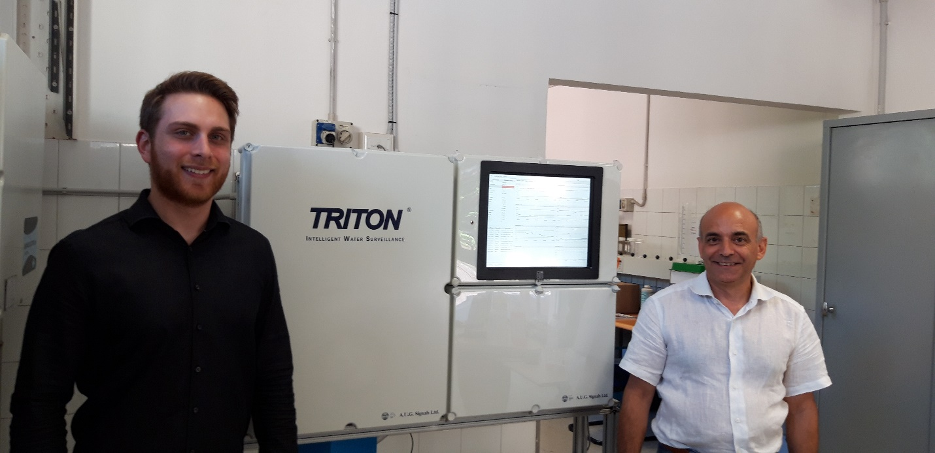
Figure 1: Nicola Bazzurro (IREN) and Alexandros Antonerias (AUG) at the field validation site located inside IREN’s Prato drinking water treatment plant (14 July, 2019).

